East West

Medical Group
March2020
Inside this Issue
1 | National Nutrition Month
2 | Acupuncture and Nutrition  Nutrition a Necessary component of Chiropractic
3 | How to use Massage for Weight loss  I
 | Important Dates to remember March17-27 Dr. Tsai out of town
 | Comics and Product of the Month
East West Medical Group
515 E Commonwealth Ave
Fullerton, CA 92832
Phone: (714) 871-7118
Fax: (714) 871-3372
www.eastwestmedicalgroup.com
March is National Nutrition Month

Eat Right Food, Nutrition and Health Tips from the Academy of Nutrition and Dietetics
Building a healthy plate is easy when you make half your plate fruits and vegetables. It’s also a great way to add color, flavor and texture plus vitamins, minerals and dietary fiber. Make 2 cups of fruit and 2 ½ cups of vegetables your daily goal. Try the following tips to enjoy more fruits and vegetables every day.
1. Variety abounds when using vegetables as pizza topping. Try broccoli, spinach, green peppers, tomatoes, mushrooms and zucchini. 2. Mix up a breakfast smoothie made with low-fat milk, frozen strawberries and a banana. 3. Make a veggie wrap with roasted vegetables and low-fat cheese rolled in a whole-wheat tortilla. 4. Try crunchy vegetables instead of chips with your favorite low-fat salad dressing for dipping. 5. Grill colorful vegetable kabobs packed with tomatoes, green and red peppers, mushrooms and onions. 6. Add color to salads with baby carrots, grape tomatoes, spinach leaves or mandarin oranges. * 7. Keep cut vegetables handy for mid-afternoon snacks, side dishes, lunch box additions or a quick nibble while waiting for dinner. Ready-to-eat favorites: red, green or yellow peppers, broccoli or cauliflower florets, carrots, celery sticks, cucumbers, snap peas or whole radishes. 20 Ways to Enjoy More Fruits and Vegetables Building a healthy plate is easy when you make half your plate fruits and vegetables. It’s also a great way to add color, flavor and texture plus vitamins, minerals and dietary fiber. Make 2 cups of fruit and 2 ½ cups of vegetables your daily goal. Try the following tips to enjoy more fruits and vegetables every day. Eat Right Food, Nutrition and Health Tips from the Academy of Nutrition and Dietetics 8. Place colorful fruit where everyone can easily grab something for a snack-on-the run. Keep a bowl of fresh, just ripe whole fruit in the center of your kitchen or dining table. 9. Get saucy with fruit. Puree apples, berries, peaches or pears in a blender for a thick, sweet sauce on grilled or broiled seafood or poultry, or on pancakes, French toast or waffles. 10. Stuff an omelet with vegetables. Turn any omelet into a hearty meal with broccoli, squash, carrots, peppers, tomatoes or onions with low-fat sharp cheddar cheese. 11. “Sandwich” in fruits and vegetables. Add pizzazz to sandwiches with sliced pineapple, apple, peppers, cucumber and tomato as fillings. 12. Wake up to fruit. Make a habit of adding fruit to your morning oatmeal, ready-to-eat cereal, yogurt or toaster waffle. 13. Top a baked potato with beans and salsa or broccoli and low-fat cheese. 14. Microwave a cup of vegetable soup as a snack or with a sandwich for lunch. 15. Add grated, shredded or chopped vegetables such as zucchini, spinach and carrots to lasagna, meat loaf, mashed potatoes, pasta sauce and rice dishes. 16. Make fruit your dessert: Slice a banana lengthwise and top with a scoop of low-fat frozen yogurt. Sprinkle with a tablespoon of chopped nuts. 17. Stock your freezer with frozen vegetables to steam or stir-fry for a quick side dish. 18. Make your main dish a salad of dark, leafy greens and other colorful vegetables. Add chickpeas or edamame (fresh soybeans). Top with low-fat dressing. * 19. Fruit on the grill: Make kabobs with pineapple, peaches and banana. Grill on low heat until fruit is hot and slightly golden. 20. Dip: Whole wheat pita wedges in hummus, baked tortilla chips in salsa, strawberries or apple slices in low-fat yogurt, or graham crackers in applesauce.
Revitalize Your Health with Acupuncture and Nutrition
Preventive medicine is defined as the part of medicine engaged with preventing disease rather than curing it. An integral part of preventive medicine, nutrition is considered the first line of defense in acupuncture and Oriental medicine as it provides the energy needed for the body to function. Good nutrition not only provides energy, it also provides the basic building blocks, vitamins, minerals, phytochemicals and antioxidants that keep the body healthy and vibrant.
A nutritional imbalance in foods consumed contributes to an imbalance in overall health. Eating an unnatural and restrictive diet can lead to yo-yo dieting and drastic ups and downs in body weight. Improper diet practices can cause malnutrition, organ damage, slow metabolic rate and other imbalances within the body. Biochemical and energetic imbalances may present themselves as pain, sleep disturbances, mood changes, abnormal digestion, headaches and menstrual irregularities.
Through the process of evaluating subtle physical signs as well as the emotional condition of a person, practitioners of acupuncture and Oriental medicine can detect health problems in their earliest stages, before a grave illness develops. Once the imbalance has been determined, a customized program can be created with a variety of treatment modalities including acupuncture, herbal therapy, tui na, qi gong in addition to food, exercise and lifestyle suggestions. Seasonal acupuncture treatments just four times a year serve to tonify the inner organ systems and correct minor annoyances before they become serious problems.
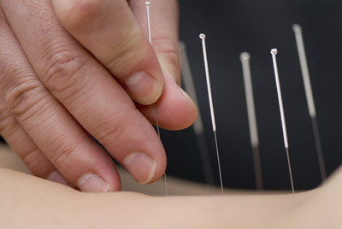

Nutrition: A Necessary Component of Chiropractic

By Amanda Donohue
A recent study showed that natural products (i.e., dietary supplements other than vitamins and minerals) remain the most common complementary health approach in the United States, according to the NIH’s National Center for Complementary and Integrative Health (NCCIH) and the Centers for Disease Control and Prevention’s National Center for Health Statistics (NCHS).(1)
As the demand for natural products rises, doctors of chiropractic (DCs) continue to incorporate nutrition into their practices. In fact, the National Board of Chiropractic Examiners’ (NBCE) Practice Analysis of Chiropractic 2015 indicates that 97 percent of DCs gave nutritional and dietary recommendations, making nutrition a common part of a treatment plan for chiropractic patients.(2)
In another study, from 2007, on “nutritional counseling in the chiropractic practice,” 80 percent of chiropractic physicians who responded incorporate some form of nutritional counseling into their practice.(3)
More than 50 percent of these DCs did not limit their nutritional counseling to patients with musculoskeletal disorders, but additionally addressed coronary artery disease, obesity, diabetes and allergies. DCs indicated a strong interest in increasing their applied clinical knowledge of nutrition through continuing education.(3)
“Chiropractic is based on the premise that the body is able to achieve and maintain health through its own natural recuperative powers, provided it has a properly functioning nervous system and receives the necessary health maintenance components. These components include adequate nutrition, water, rest, exercise and clean air,” according to the NBCE’s Practice Analysis of Chiropractic 2015.(2)
“As an owner of a private practice, I have found that people are nutritionally sick, and I believe nutrition answers my patients’ questions,” says Donald Feeney, DC, DACBN, CCN, executive director and director of publications of ACA’s Council on Nutrition.

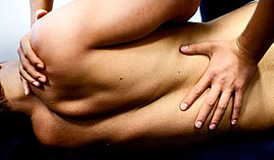

How to Use Massage for Weight Loss
By Malia Frey

If you’re looking for a way to lose weight that doesn’t involve diet or exercise, you’ll find plenty of information on the internet about massage. Many websites recommend abdominal massage and other forms of massage therapy as effective weight loss methods. But before you call your local massage therapist to set up an appointment, you should find out what massage can and cannot do if you are trying to lose weight.
Weight Loss Benefits of Massage
Massage therapy can work wonders for people who are trying to lose weight. But massage treatment alone doesn’t make weight loss occur.¹﻿ So if you are hoping that a massage will reduce your cellulite, decrease your belly fat or shrink your thighs, you’re likely to be disappointed.
But massage can make it easier for you to stick to a diet and an exercise program. These are just some of the benefits that dieters may experience with massage therapy:
- Decreased stress
- Reduced anxiety
- Decreased muscle soreness
- Reduced back pain²﻿
- Improved range of motion
- Improved mental state³﻿
- Better sleep
"Massage is also a wonderfully healthy way to reward yourself for all of the hard work you are doing!” says Bethany O'Shei of Clay Health Club + Spa in New York City.⁴﻿ Bethany has been a licensed massage therapist for eight years and says she works with many clients who use massage along with a comprehensive program of diet and exercise to lose weight.
Massage can be a helpful part of your complete weight loss program. But it’s important to keep your expectations in check.
Focus on eating a healthy, calorie-controlled diet and getting enough physical activity each day. Then find a licensed massage therapist in your area who can help you to keep your body feeling strong, flexible and relaxed.
Important Dates to Remember March 17, 2020-March 27, 2020 Dr. Tsai will be out of town
Dr. Hen will cover.

Product of the Month
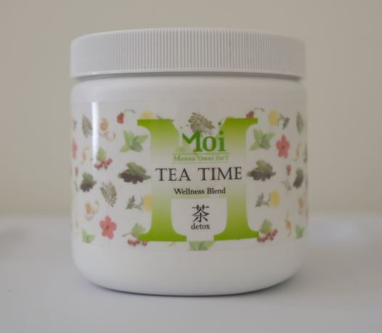
Tea time Wellness blend Tea is formulated using herbs that promote health and balance in the body. We combine ancient wisdom and modern technology to help patients achieve a healthy lifestyle.





